* **Activity 4:**

HAVING Clause with Subqueries

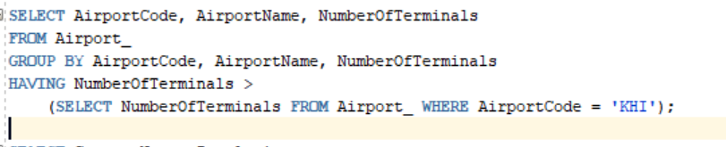

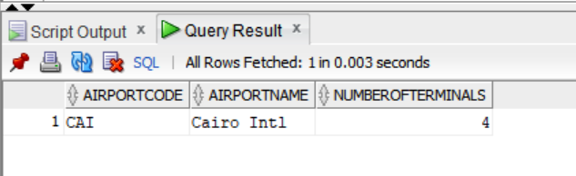OUTPUT: